MAKERERE****UNIVERSITY

COLLEGE OF COMPUTING AND INFORMATION SCIENCES

DEPARTMENT OF NETWORKS

BACHELOR OF SCIENCE IN SOFTWARE ENGINEERING (YEAR 2) RECESS TERM 2 (BSE 2301) PROPOSAL FOR:

GROUP 17

**PROJECT LEADER**: KIGGUNDU ISMAIL SSALI

GROUP MEMBERS

|  |  |  |  |
| --- | --- | --- | --- |
| **NAME** | **REG. NO** | **STUDENT NO.** | **SIGN** |
| NUWASIIMA BRENDA | 16/U/2093 | 216002098 |  |
| ABUBAKARI SIMBA | 16/U/2618/PS | 216010199 |  |
| KIGGUNDU ISMAIL SSALI | 16/U/5959/PS | 216004419 |  |
| AYESIGA TONY NSUBUGA | 16/U/4043/PS | 216012265 |  |

**ADVISOR**: NOAH KANGE

SUBMITTED IN PARTIAL FULFILLMENT OF THE REQUIREMENTS FOR THE SOFTWARE ENGINEERING RECESS PROJECT BSE 2301

4TH JULY, 2018

Software Design Document

For

PRODUCT REVIEW ANALYSIS PROJECT

Version 1.0

Prepared by AYESIGA TONY NSUBUGA, NUWASIIMA BRENDA, ABUBAKARI SIMBA AND KIGGUNDU ISMAIL SSALI

GROUP 17

July 04, 2018

Table of Contents

**1.** **Introduction** 5

**1.1** **Purpose** 5

**1.2** **Scope** 5

**1.3** **Definitions, acronyms & abbreviations** 5

**1.4** **References** 5

**1.5** **Overview** 6

**2.** **System Overview** 6

**2.1** **Design considerations** 7

**2.1.1** **Design assumptions and constraints** 7

**2.1.1.1** **Design assumptions** 7

**2.1.1.2** **Design constraints** 8

**Design goals and guidelines** 8

**Reliability** 8

**Usability** 8

**Portability** 8

**Extensibility** 8

**3.** **System Architecture** 8

**3.1** **Architectural Design** 8

**3.2** **Decomposition Description** 9

**4.** **Data Design** 10

**4.1** **Data Description** 10

**4.2** **Data Dictionary** 10

**5.** **Component Design** 11

**Module 1: Grammar check** 11

**6.** **Human Interface Design** 12

**6.1** **Overview of User interface** 12

**6.2** **Screen Images** 12

**7.** **Requirements Matrix** 15

Table of Figures

Figure 1. Context Diagram. 8

Figure 2. Conceptual Diagram 10

Figure 3. Decomposition diagram. 10

Figure 4. Level 1 Diagram. 11

Figure 5. Module 1 representing grammar check. 12

Figure 6. Rating check module. 13

Figure 7. Home page 14

Figure 8. Ratings page 15

Figure 9. Word counter page. 15

# **Introduction**

The Software Design Document is a document to provide documentation which will be used to aid in software development by providing the details for how the software should be built.

The project is to create a product review analysis system that should be able to analyse grammar in product reviews, compare product ratings and display products with the highest and least rating, return frequency of particular word(s) in product reviews.

## **Purpose**

The purpose of this document is to present a detailed description of the designs of the Product Review Analysis system created for online market portals, product manufacturers, customers etc. Firstly, this document is intended for the programming group which is Group 17, to use the designs as guidelines to implement the project. Equally, this document is intended for the system architects, system testers, and system analysts. Lastly it could be used by customer representatives, user support agents and marketing stuff.

## **Scope**

The scope of the SDD is to provide information about the design procedure of the system. It also specifies the structure and design of some of the modules discussed in the SRS. It also displays some of the use cases that had transformed into sequential and activity diagrams. The class diagrams show how the programming team would implement the specific module.

## **Definitions, acronyms & abbreviations**

|  |  |
| --- | --- |
| PRAS | Product Review Analysis System |
| SDD | Software Design Document |
| SRS | Software Requirements Specification |
| CSV | Comma separated values |
| GUI | Graphical User Interface |

## **References**

[1] IEEE Software Engineering Standards Committee, “IEEE Std 830-1998, IEEE Recommended Practice for Software Requirements Specifications”, October 20, 1998.

[2] Davis M A, “Just Enough Requirements Management: Where Software Development Meets Marketing”, New York, Dorset House Publishing, 2005.

[3] Technical Design Document. Available:

<http://ec.europa.eu/idabc/servlets/Doc7e17.doc?id=18632>

## **Overview**

This document has 8 sections that explain its use to the user.

The **Introduction** defines the system’s objective and the summary of the system functionality so as to give the reader a good understanding of the system goals.

The **System Overview** explains to the reader the general system functionality and its design. This section describes the requirements of the proposed software architecture.

The **System Architecture** has the detailed view of the different conceptual requirements for setting up the system in terms of hardware and software.

The **Data Design** defines the data storage techniques and the format of the data for each of the stored data files.

The **Component Design** describes how the different components of the system interact to satisfy the user needs.

The **Human interface** explains to the reader the needed skills of the system’s interface in order to be able to interact freely with the system.

The **Requirements matrix** shows the system components that satisfy each of the functional requirements from the SRS document.

The **Glossary** is unused in current document due to Section 1.3 Definitions, Acronyms, and Abbreviations providing terms and definitions for internal use of the document.

# **System Overview**

The Product Online Analysis system is to be developed with the aim of analysing and visualizing Grammar which includes grammatical errors, Punctuation etc., Product ratings and Frequency of words in online product reviews from different online market portals. The system context diagram below shows the system functionalities.

**Context Diagram**

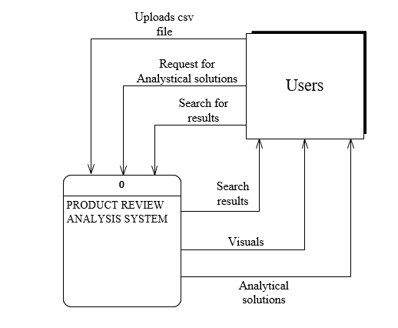

Figure . Context Diagram.

## **Design considerations**

# **Design assumptions and constraints**

# **Design assumptions**

While designing this project, we needed to make some assumptions related to software and hardware. First of all, our system is intended to run on particular operating system such as Windows, Linux and IOS.

Related to hardware, our system will run on various computer systems provided a user can input data via devices such as keyboards and view output on the monitor and smartphone screens.

The user of the system should be familiar with the basic operation of a computer.

# **Design constraints**

# **Design goals and guidelines**

# **Reliability**

Our main purpose is to make a system to run without any problems or bugs. This shall be achieved through various testing strategies while designing the system in order to improve the performance and decrease the number of errors that will occur.

# **Usability**

The proposed system is intended to be simple and user friendly to all users. The user interface is to be kept simple so that pure functionality is gathered without being bothered with lots of menus and buttons.

# **Portability**

The system will be implemented on environments such as android, windows, Linux and IOS which makes the system low-portable.

# **Extensibility**

The system is designed to be extensible in terms of features and functionalities. It will be possible to add new features to system with time.

# **System Architecture**

## **Architectural Design**

The diagram below shows how the system was decomposed giving a general understanding of how the individual sub systems work together.

**Conceptual Diagram**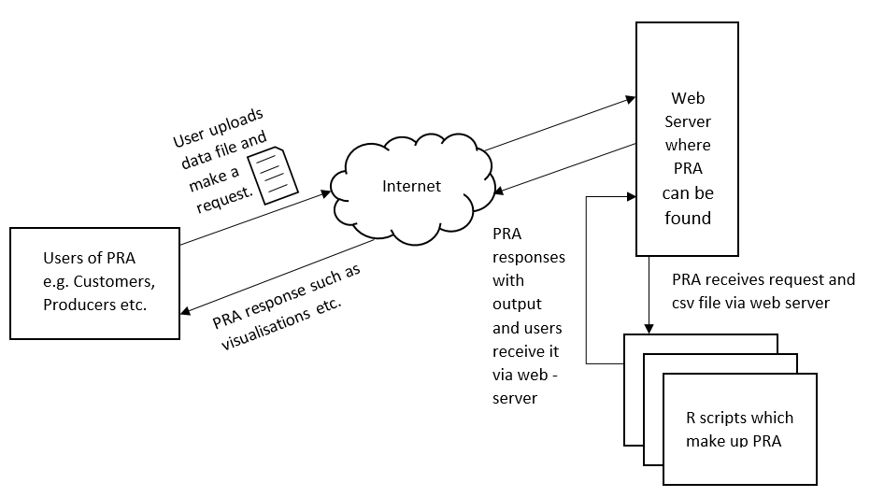

Figure . Conceptual Diagram

## **Decomposition Description**

The system functionality has been broken down and is represented as a functional decomposition diagram and data flow diagrams.

**Functional Decomposition diagram**

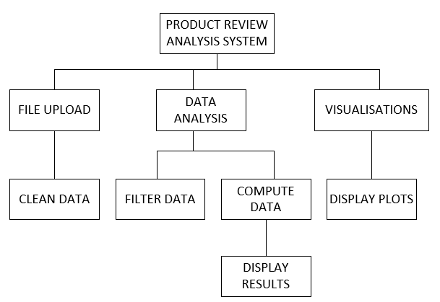

Figure . Decomposition diagram.

**LEVEL ONE DATA FLOW DIGRAM**

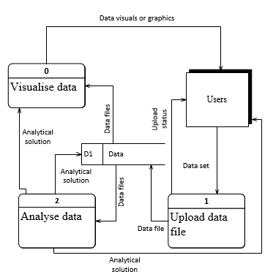

Figure . Level 1 Diagram.

# **Data Design**

## **Data Description**

The system will not have any database. The user will be required to upload a csv file having a data format explained in section 4.2. This file will be uploaded for every user session and will only be stored temporarily.

## **Data Dictionary**

The table below shows the expected contents of each work sheet in the data store.

|  |  |  |
| --- | --- | --- |
| **Column** | **Description** | **Data type** |
| Reviews | This column should contain all the customer reviews about the Product. | String |
| Product Rating | This column should specify the rating of a particular product. | Numeric |
| Product | This column should contain different products being sold. | Character |
| Review title | This column should contain the overcome feeling expressed in the review | String |

# **Component Design**

# **Module 1: Grammar check**

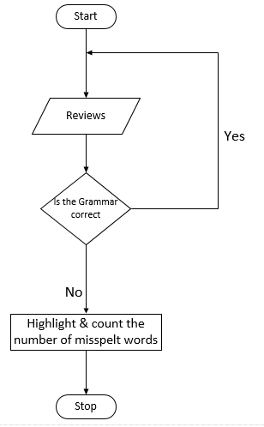

Figure . Module 1 representing grammar check.

**Module 2: Ratings**

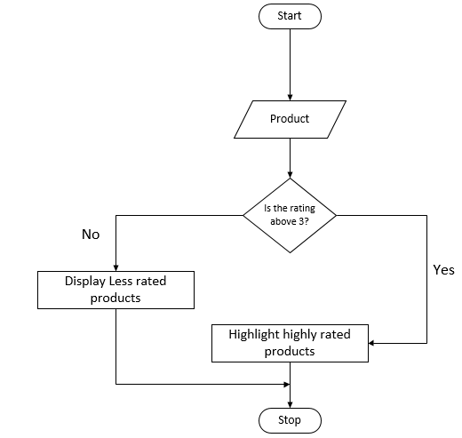

Figure . Rating check module.

**Module 3: Word counter**

**Module 4: Data Analysis**

This module is the core part of the system and will be called frequently and its results will depend on the user commands. The user will choose which parameters to be analysed and how they should be analysed using the graphical interface.

Module input: Product review csv file.

Module output: Analysis results

**Module 5: Graphical Representation of results**

The analytical results from module 4 will be presented in a graphical view based on the user selections. A number of graphical features including but not limited to line graphs, bar graphs, pie charts, box plots will be used by this module to display data to the user. The user will select the tool they wish to use to view the results.

Module inputs: Analysis results

Module outputs: Graphs

# **Human Interface Design**

## **Overview of User interface**

The system users will be required to have a smartphone or computer with Internet access. Additionally the users will be required to be computer literate. In this program there are four main menus: Home menu, Grammar check, Ratings and Word counter.

In the Home menu, the users will be able to view a brief description of the Product Review Analysis system and its system features. In the Grammar check menu, users will be able to view the most misspelt words, review Length, Punctuations in reviews etc.

In Ratings menu, users will be able to search for a product and its product rating will be displayed. Also a list of the highly rated and least rated products will be displayed initiated before any action. In Word counter menu, a word cloud will be displayed showing the most frequently used word and also a table of the words will be displayed as shown in the illustrations below.

## **Screen Images**

**Home Menu/Page**

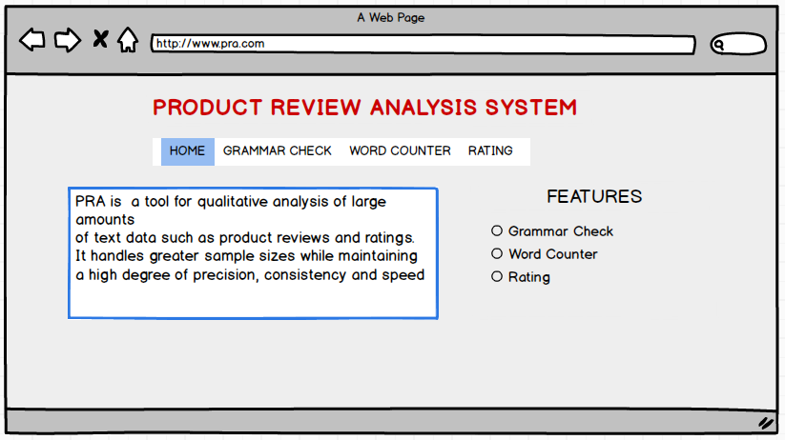

Figure . Home page

**Ratings page**

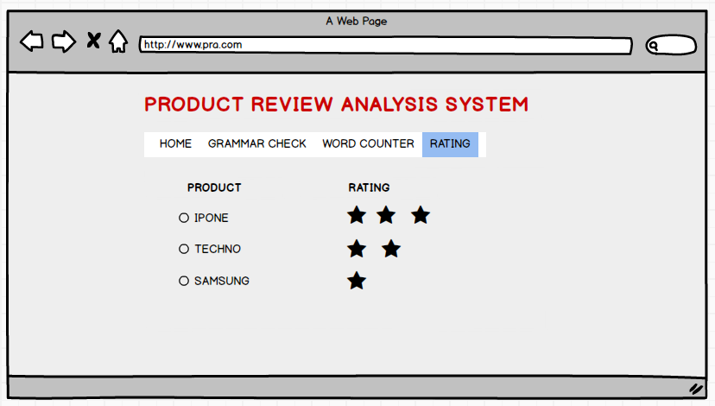

Figure . Ratings page

**Word Counter**

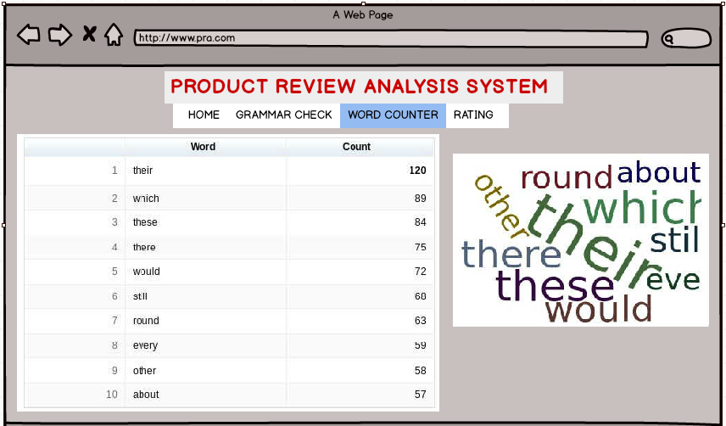

Figure . Word counter page.

# **Requirements Matrix**

**Requirements table**

|  |  |
| --- | --- |
| **Functional Requirement** | **Reference Section in SRS** |
| External Interface Requirements | 3 |
| System features | 4 |
| Other non-functional requirements | 5 |